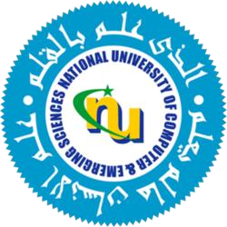

ASSIGNMENT #2

Course: Compiler Construction
Instructor: Ms. Nirmal Tariq

Ruhab Ahmad (23I-0559)
Hasan Altaf (23I-0698)
Degree: Computer Science
Section: E
FAST - NUCES

